1.1 The purpose of this document is to provide a specification for the Online PGA (Post Graduate Application) Approval System for the School of Electrical and Information Engineering. This document will serve as a base for consideration of further design and development of the System. Additionally this documentation will provide initial elicited business rules and proposed UI design.

The purpose of this project is to provide a centralised and paper free platform to replace the current paper-based approval process.

1.2 Document Conventions

This document will evolve with the project, and as such the document will be released in several iterations. Feedback and changes will be provided for each iteration and each section of this document is assumed to hold true for each release.

1.3 Intended audience and reading suggestions

The software requirements document at this stage is intended for:

* Developers who can review system requirements and consideration for further design and development of the system.
* Clients who can verify the scope and requirements of the project.

1.4 Project Scope

This project is intended to digitize the current (as of August 2018) paper-based Post Graduate Approval Process for the School of Electrical and Information Engineering at the University of the Witwatersrand, Johannesburg. Further changes to the application process will be discussed and considered in future and if approved, will be added to this document.

1.5 References

<Intentionally left blank>

2. Overall Description

2.1 Product Perspective

This system is self-contained and independent of any other systems or products available on the market.

2.2 Product Features

The basic version of the system should provide:

* Applicant document repository and management
* Interface for the upload of Application related document
* Interface for the PGO to select a Research Group or an identified Supervisor
* Automatic Email Notification for Evaluators and Applicants
* Generation of acceptance/rejection letters
* Bespoke views for each user class.
* Access permission management for each system view

2.3 User classes

PGO

* The Post Graduate Officer who deals with the administration of each Application

Evaluator

* The Research Group or Supervisor who evaluates whether they are willing to supervise the Applicant based on their Application.

PGC

* Post Graduate Coordinator who verifies that all university/faculty/school rules have been followed and acceptance criteria met. With consideration from the Evaluator and aforementioned rules and acceptance criteria signs off the final decision to accept or reject the application.

PGFO

* Post Graduate Faculty Officer who communicates the outcome of the Application to the Applicant.

2.4 Operating Environment

This proposed system is platform independent as it is a web application.

Software Requirements:

Hardware Requirements:

2.5 Requirements

* The System should allow a PGO to capture PG Application supporting documents.
* The System should allow a PGO to select a Supervisor or Research Group to forward the Application to.
* The System should allow for email notification to Applications for a Supervisor or Research Group of pending Applications to review.
* The System should allow for email notification to Applicants of the outcome of Submitted Application.
* The System should allow for email notification to Applicants of the outcome of Submitted Application.
* The System should have custom views pertaining to each Actor of the System.
* The System should enforce validation and verification on all data within the system.

3. System Features:

* Document repository and management  
  **Description**: Upload Application document and supporting documents to a centralized repository  
  **Requirements**:

1. The System should allow a PGO to upload PG Application and supporting documents.

* Interface for the PGO to select a Research Group or an identified Supervisor  
  **Description**: PGO selects a correct Research Group or Supervisor for a PG application  
  **Requirements**:

1. The System should allow a PGO to select a Supervisor or research group to forward the Application to.

* Automatic Email Notification for Evaluators   
  **Description**: Evaluator is notified of Application to review **Requirements**:

1. The System should allow for email notification to a Supervisor or Research Group of pending Applications to review.

* Acceptance/rejection letter generation   
  **Description**: Generate a PDF document of the Application outcome  
  **Requirements**:

1. The System should allow for the generation of an acceptance or rejection PDF with all required information.

* Automatic Email Notification for Applicants  
  **Description**: Applicant is notified of Application outcome. **Requirements**:

1. The System should allow for email notification to Applicants of the outcome of Submitted Application.

* Bespoke views for each user class and Access permission management for each system view  
  **Description**: Allow different users to access the system

**Requirements**:

1. The System should have custom views pertaining to each Actor of the System.
2. The System should enforce validation and verification on all data within the system.

4. Proposed Design

4.1 Proposed Hardware Architecture

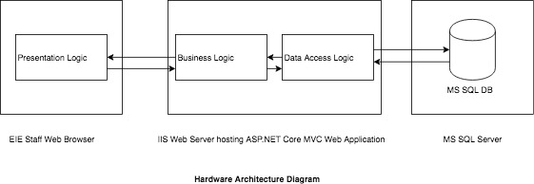

4.2 Proposed Software Architecture

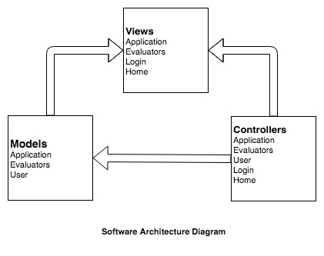

4.2 Use case model

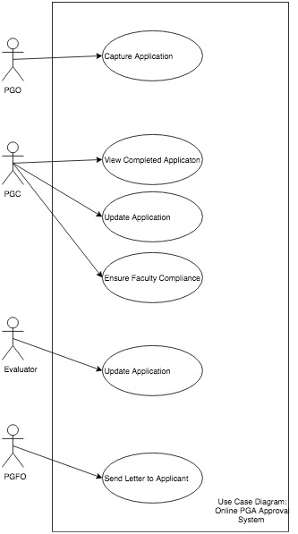

5. Team Information

Front End Tasks

* Design of Views
* Ensure Design Conventions are met
* Relevant Data Capture
* Front end validation
* Unit testing

Back end Tasks

* Model design
* Verify correct data transfer
* Custom Models for Views
* Security
* Integration Tests
* Unit Tests